# **Design and Implementation of half substrate**

**Objective:**

The **substrate** material is usually formed into or cut out as thin discs called wafers.

It may contain with some two input and find the output of XOR gate and A’B as like output.

**Theory:**

From this figure, we can find the output as like ‘ON’ or ‘OFF’. In these sequence, there will be find the value of XOR gate as D output and the barrier output as B(A’B). It may be used for the fabrication of integrated circuit.

The Table can be written as:

|  |  |  |  |
| --- | --- | --- | --- |
| A | B | D | B |
| 0 | 0 | 0 | 0 |
| 0 | 1 | 1 | 1 |
| 1 | 0 | 1 | 0 |
| 1 | 1 | 0 | 0 |

**Circuit Diagram**

If one input 1,other input 0 then output will be as

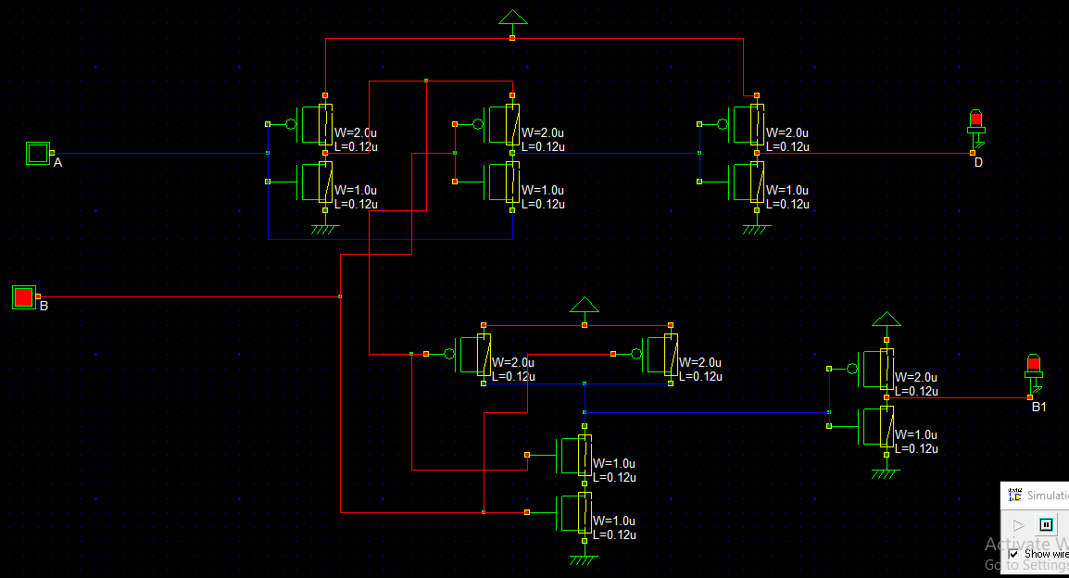

If two input same as 0, then output will be OFF.

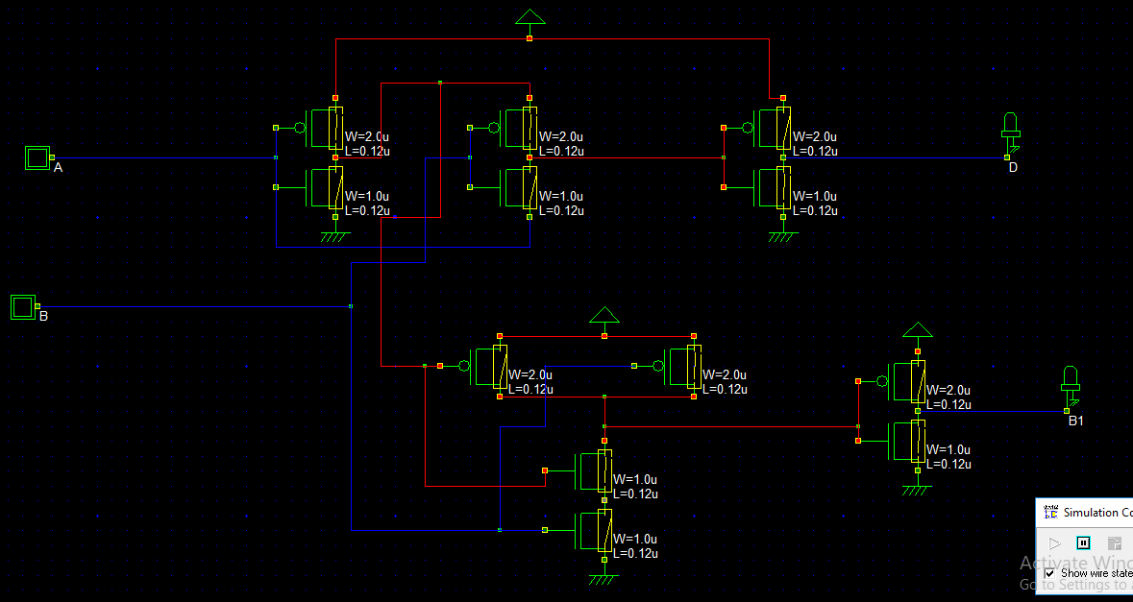

**Verilog File**

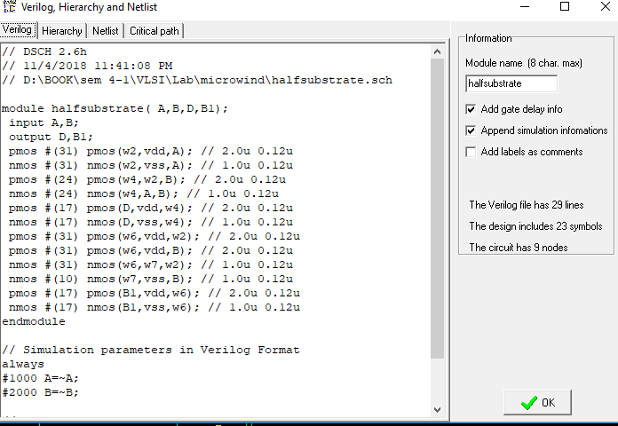

**Layout Diagram**

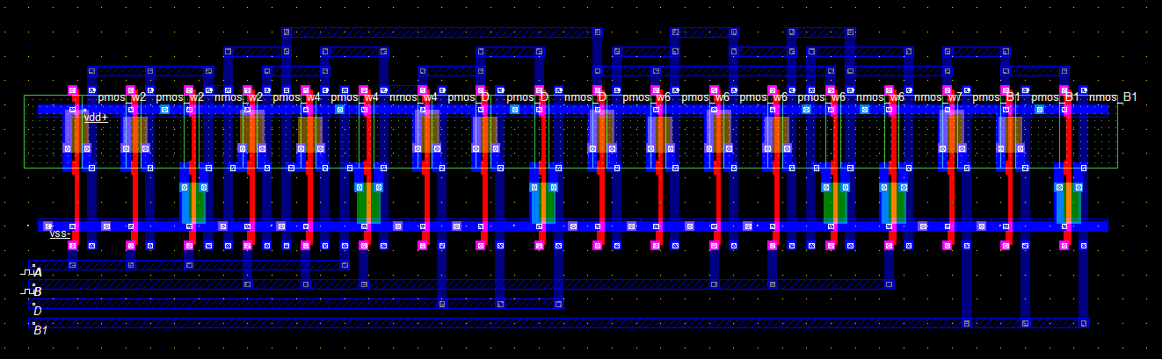

**Timing Diagram**

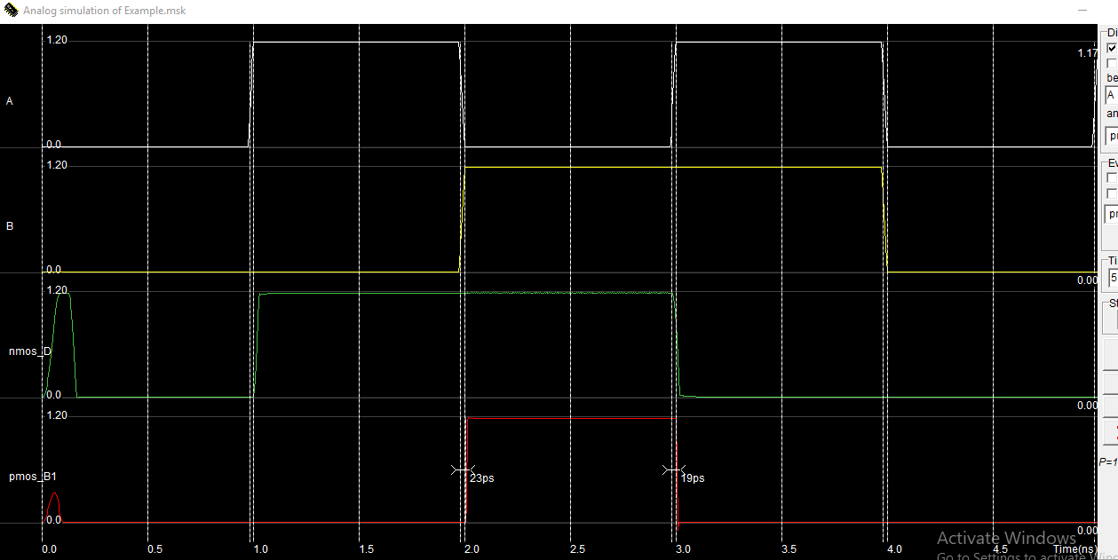

**Stick Diagram**

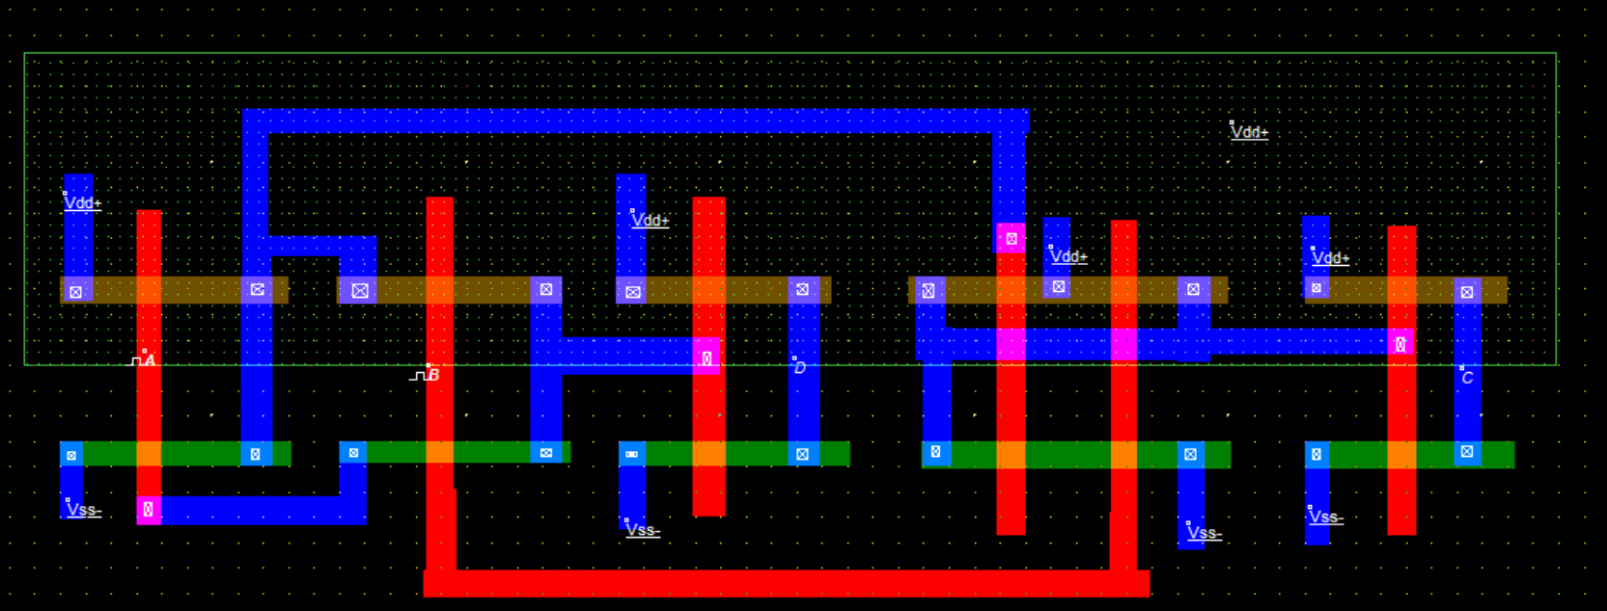

**Timing Diagram**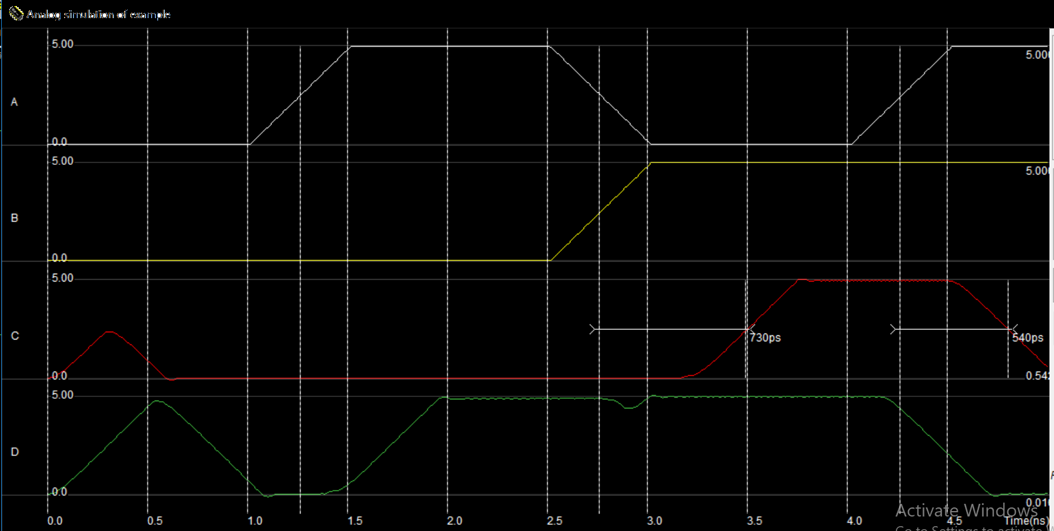

**Discussion**

A Substrate is a semiconductor. Substrate is used in a converting process such as printing or coating to generally describe the base material onto which, e.g. images, will be printed. Base materials may include: plastic films or foils,